HERDSA Webinar planning and hosting tips!

Creating the zoom webinar
When setting up the zoom meeting, follow the normal process of scheduling a future meeting. I found the only difference for this meeting was to click the ‘Registration’ box. This allows participants to register for the session and you do not need to create a separate registration in a different platform. Also add the presenter as ‘Co-host’ when setting up the meeting so that you can both screen share and control the settings and make a recording of the webinar.

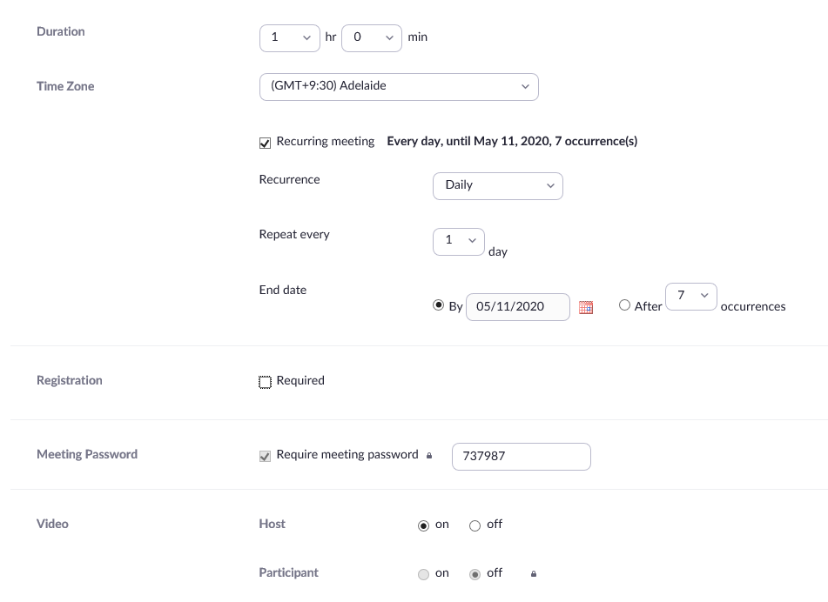
Also set up the meeting with video and audio off for participant, so that when people enter zoom the settings are already conducive to the webinar presentation environment. You may like to review all of the settings as they seem to keep changing their default setting.
With the registration option triggered, once the meeting is set-up, you will have a registration link to share with HERDSA office for promotion. Participants need to log into the zoom system to register via the registration link, then they are provided the zoom link for the meeting and can elect for the webinar to be added to their calendar.
Approval and Promotion of webinar
The HERDSA office is happy to promote the webinar series via the website and through the HERDSA weekly notices. You will see that the webinars have a place on the moving top banner of the HERDSA site, once people click into the link, the information for the up-coming webinar is featured.
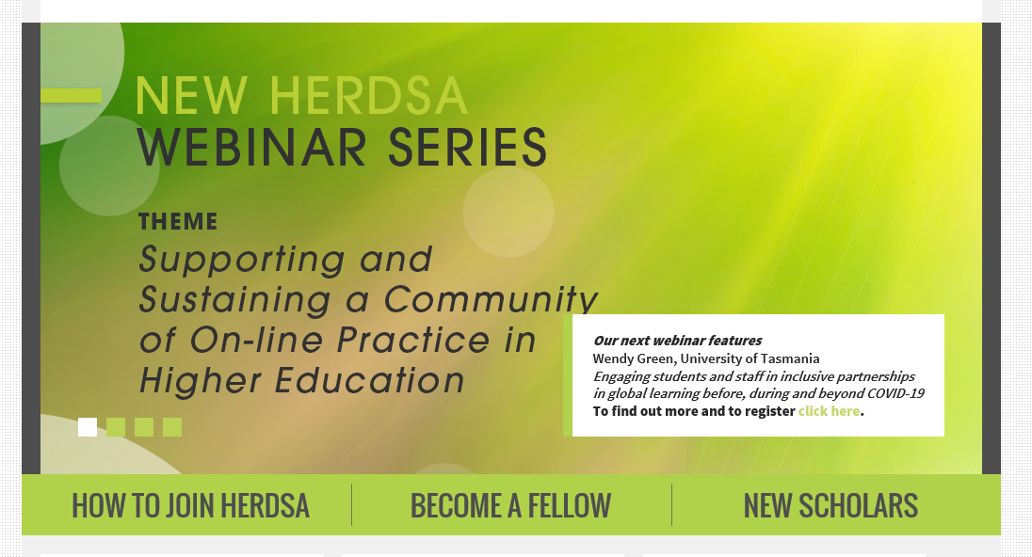

For approval of your webinar please fill in the form located on the webinar page https://www.herdsa.org.au/herdsa-webinar-series Send the form to Kwong Nui Sim from the HERDSA Executive kwongnui.sim@aut.ac.nz who is looking after the HERDSA Webinars and cc a copy to office@herdsa.org.au. Once your webinar has been approved the information on the form will be inserted into the website and advertised in the HERDSA Weekly email notices. You will receive an email advising you of approval.
This was the text I submitted to promote the SA webinar in the weekly notices:
HERDSA state Branch chairs and friends are launching a webinar series next week guided by the theme ‘Supporting and Sustaining a Community of On-line Practice in Higher Education’. Running fortnightly or monthly on a Thursday (3pm NZST, 1pm AEST & 11am AWST), HERDSA members can log into a zoom session to explore topics we hope are helpful to people working in Higher Education during this challenging period.
Our first webinar is scheduled for Thursday 30th April on the topic of ‘Enabling online education: access/equity, engagement and innovation in digital spaces’ by Jennifer Stokes from the University of South Australia.
Please check out the HERDSA website for webinar details. https://www.herdsa.org.au/

Facilitating the zoom session
To support my presenter, I tended to the following tasks:
- Added a welcome slide to her powerpoint that featured the HERDSA logo and guidelines for the webinar (re. microphones and Q & A and webinar being recorded). If you haven’t added the presenter as co-host when setting up the webinar, you can add them once in the zoom meeting so that you can both control the settings. Remember to hit record (I almost forgot!).
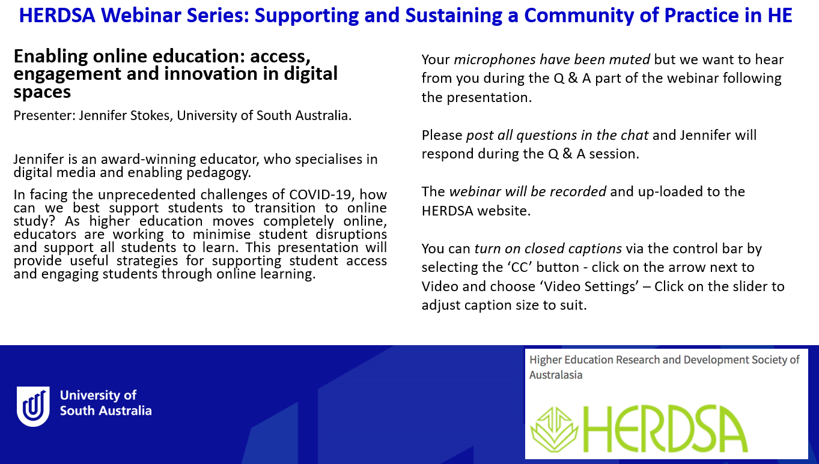
- Gave a formal welcome to the webinar.

On behalf of the HERDSA Executive, welcome to the first webinar in the HERDSA series on the theme of ‘Supporting and Sustaining a Community of On-line Practice in HE’. It is great to have so many of you participating today.
My name is Sarah Hattam and I am Program Director at the University of South Australia and the SA Branch chair.
I would like to first acknowledge I am on Kaurna Land and pay my respects to the Kaurna peoples’ spiritual relationship with their country. I also acknowledge the diversity of Aboriginal peoples, past, present and future.
From all of us at HERDSA, we hope that everyone has been keeping well and managing the distinct changes that have occurred to our working and personal lives due to Covid-19. As a collective, the HERDSA executive share the concern about how to support HERDSA members through these unusual times. This series of webinars aims to provide knowledges about best practice approaches to on-line teaching as well as the opportunity to connect with others working in HE.
The topic of today’s webinar is ‘Enabling online education: access, engagement and innovation in digital spaces’, presented by Senior Lecturer Jennifer Stokes from the University of South Australia. Jennifer is an award-winning educator, who specialises in digital media and enabling pedagogy and her presentation will provide useful strategies for supporting student access and engaging students through online learning.
Before I hand over to Jennifer, I would like to just request that we keep our microphones muted throughout the presentation and post any questions you have in the chat for Jennifer to respond in the Q & A session. Jennifer will present for approximately half an hour, leaving the remaining time for Q & A.

I would also like to let you know the webinar will be recorded and up-loaded to the HERDSA website later this week.
You can turn on closed captions via the control bar by selecting the ‘CC’ button - click on the arrow next to Video and choose ‘Video Settings’ – Click on the slider to adjust caption size to suit.
Finally, I would like to make a special mention and thank you to Jennifer Ungaro for her work in promoting the webinar series via the HERDSA website, and to our President of HERDSA Denise Chalmers for her support. Please keep your eye out for future promotion of up-coming webinars.
Thank you again to everyone for participating today and I will pass over to Jennifer for her presentation.

- Followed the chat contributions and posted responses to questions and helped trouble shoot any issues with the technology. I also cut and pasted any specific questions for my presenter onto a word document that I then added back into the chat box when Jennifer finished so she didn’t have to scroll through the chat to look for them.

- Prompted her with themes/topics of interest from the chat discussion when there was a lull in the discussion from the participants.

- At end of scheduled time, thanked presenter and participants, let audience know about up-coming webinar and the video recording would be available via the HERDSA website.

Follow-up
The recording of the webinar can be downloaded and put into YouTube so it is accessible for others to watch the webinar. My presenter did this herself and then I provided the link to the YouTube channel that I have given to Jennifer at national office to add to the HERDSA website. I can consult with my colleague about this process if anyone needs help with this. I also submitted a message for the HERDSA notices to let members know the video recording was available to watch.
Good luck everyone and I look forward to your webinar sessions – sing out if you have any questions or things I haven’t covered here.
Warm regards
Sarah Hattam
SA Branch Chair

